Project summary:

To create a randomized continental map generator for use in world creation.

Target audience:

People who need to create world maps, i.e. dungeons & dragons players, writers, video game creators.

Key features:

1. Randomized map generator. It would use hexagonal tiles to build biomes and a randomized continent shape.
2. The user can select the number of biomes, which biomes they want to appear and the size of the continent.
3. Option to save the map to the desktop as a .png, .jpg, etc

We will use Java and IntelliJ IDEA.

We will release it for desktop Java use.

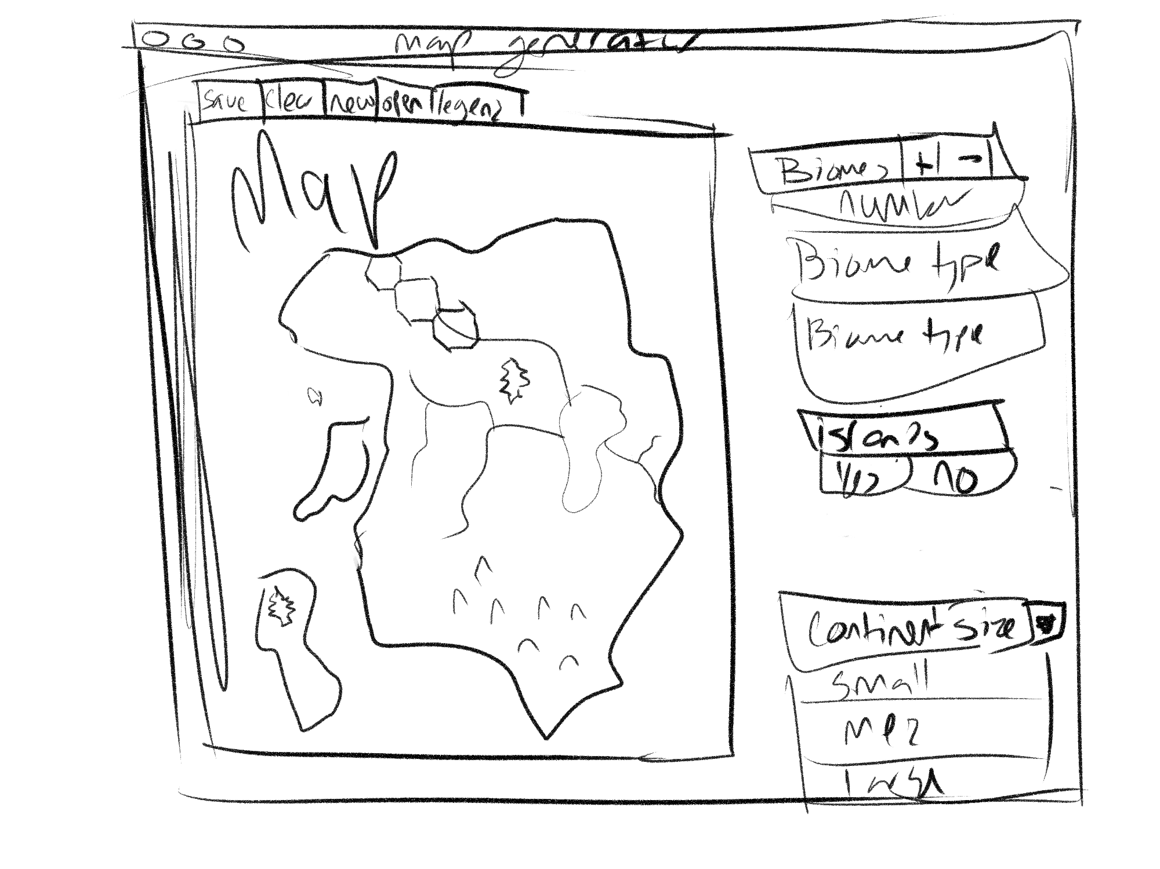

[ricesnow@bsu.edu](mailto:ricesnow@bsu.edu)

User Story (3-5 well-defined user stories)

* name
* conditions of satisfaction (SMART)
* conversation
* ----------
* Listing user story names
* Priorities
* Articulate conditions of satisfaction
* [break down epics]
* <https://www.mountaingoatsoftware.com/agile/user-stories> <- Mike Cohn’s Format

Product Backlog (SCRUM - Means of working in a group and producing software)

* prioritized list of user stories

Open Source Map Generator

<http://www-cs-students.stanford.edu/~amitp/game-programming/polygon-map-generation/>

That is an awesome website with a map generator much like what we want to do. It is all open source and even comes with a tutorial on how to make your own!!!!

Source code - <https://github.com/amitp/mapgen2>

Rule of Three Interpretations

* come up with three possible interface ideas